# It's Elliot Stabler: "Law and Order: Organized Crime" Films in Middlesex County

By MAUREEN BERZOK

March 8, 2021 at 6:16 PM

Share to FacebookShare to TwitterShare to EmailShare to PrintShare to More**11**

New episode shot nearby in Middlesex!*Credits: Middlesex County, New Jersey*

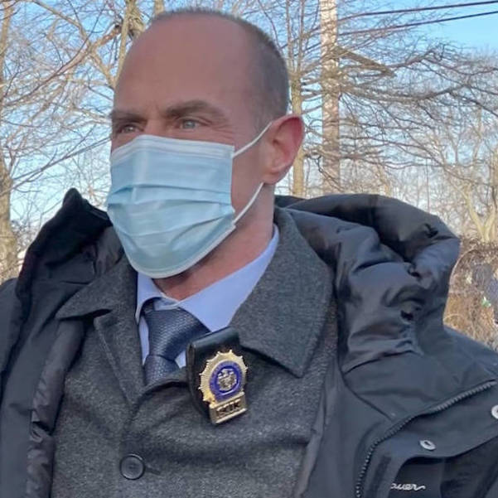

Did you catch that badge number? 6313*Credits: Middlesex County Office of Information*

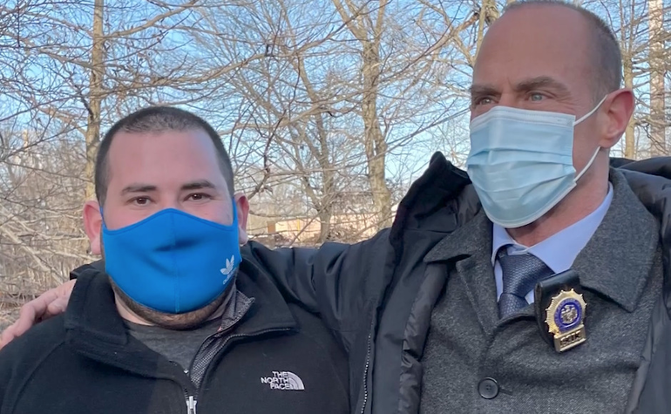

Adam Brooks, videographer for the Middlesex County Office of Marketing, along with Christopher Meloni of "Law and Order: Organized Crime."*Credits: Middlesex County Office of Information*

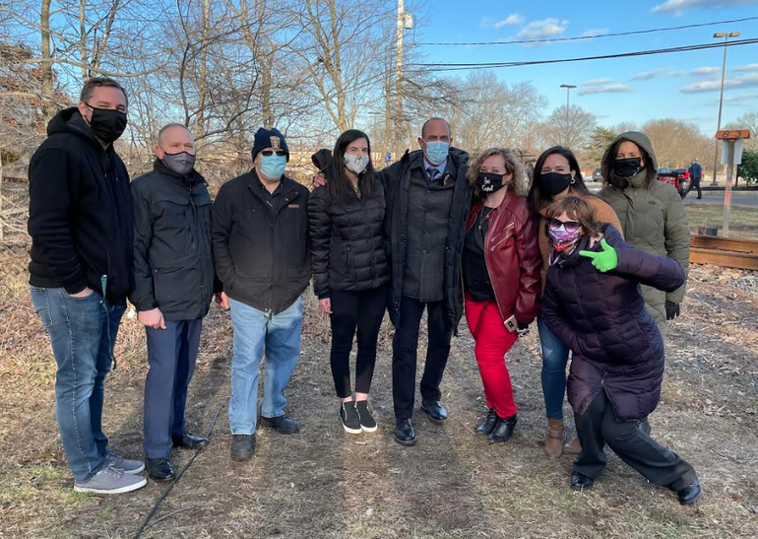

The Middlesex County crew with Christopher Meloni of the new NBC series "Law and Order: Organized Crime."*Credits: Middlesex County Office of Information*

MIDDLESEX COUNTY, NJ - This Thursday, Middlesex County officials got to meet [**Chris Meloni**](https://www.facebook.com/christopher.meloni.5209?__cft__[0]=AZWAc83syBhB2R97vEcXcwldfle1GZklJ5jGgzvPH8KpnIRYxXN8iTXzhkBUObUtl8rz9LB0EH8IdOmcmO8G1o2PKqRFNvCgHECQTOFWZxW-JqyC7W0B-5onbMO1IUKcRuEZLiXO9Qoy8-L3zD5i6l4tzduTzX9doYhxsEggYYxkww&__tn__=-]K-R) and some *Law and Order: Organized Crime* crew members as they set up to film at the Middlesex County Prosecutor’s Office Training Center in Edison. Filming gave some locals a behind-the-scenes look at the production of the new series. However, there are no spoilers here, as the county has signed a document requiring silence about the much-anticipated episode.

On April 1, NBC will run a "crossover" episode of the popular *Law and Order: SVU* series which has aired on the network for 22 years, introducing the character of Elliot Stabler in 1999. In the first episode of the show's thirteenth season, Stabler abruptly retired from the police force. He remained in the active memory of Olivia Benson (Mariska Hartigay,) nonetheless. Loyal viewers expect plenty of sizzle between the former partners in this reunion episode which introduces *Organized Crime* as yet another branch of the *Law and Order* tree of crime programs.Crime

At 9:00 pm on Thursday, April 1, the 2-hour"crossover" begins with an episode of *SVU*, leading into the premiere of *Organized Crime* at 10:00

**Sign Up for East Brunswick Newsletter**

Our newsletter delivers the local news that you can trust.

This site is protected by reCAPTCHA and the Google [**Privacy Policy**](https://policies.google.com/privacy) and [**Terms of Service**](https://policies.google.com/terms) apply.

Starting over where it all began, Detective Stabler (Christopher Meloni) rejoins the ranks to take on [**New York’s most devious crime syndicate**](https://www.nbc.com/law-and-order-organized-crime) with a new task force.

After a devastating loss that rocks him to his core, Stabler must rebuild his life and career in an evolving criminal justice system, facing his past and working to making things right.

According to *TV Guide*, series creator [**Dick Wolf**](https://en.wikipedia.org/wiki/Dick_Wolf) named *SUV's'* two lead detectives after his son, Elliot, and his daughter, Olivia. Meloni was nominated for an [**Emmy Award**](https://en.wikipedia.org/wiki/Emmy_Award) in 2006, in the category of Outstanding Lead Actor in a Drama Series, for his role as Elliot Stabler.